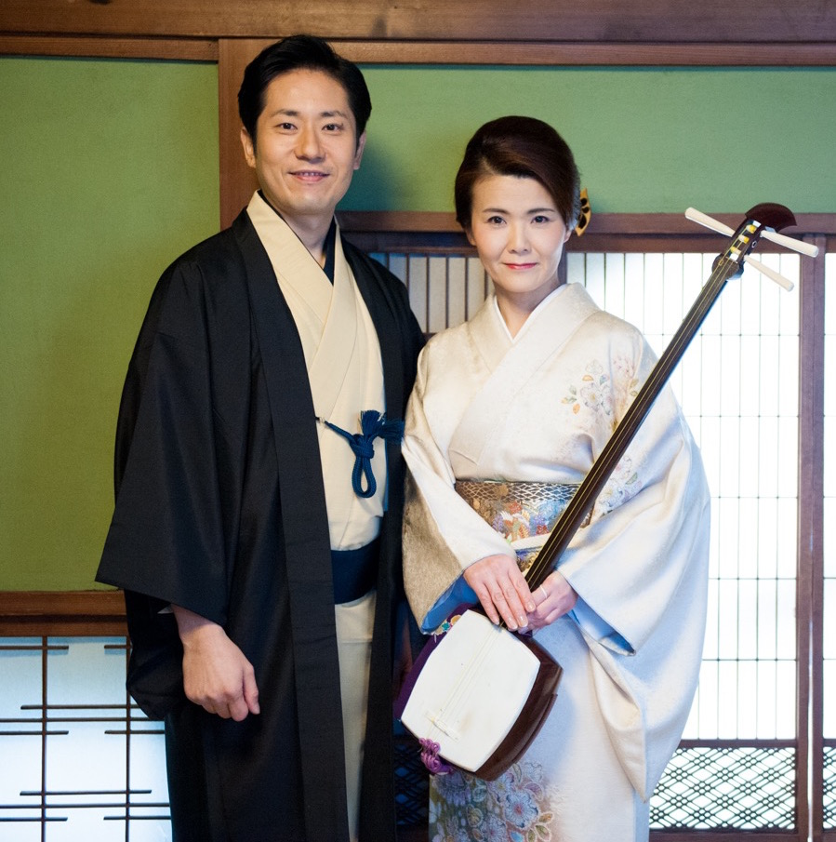
MARU-YA（山本ゆきの、中井智弥）
「MARU-YA」2017年1月結成。山本ゆきの（三味線、唄）と中井智弥（二十五絃箏）の2人によるお座敷唄エンターテイメントユニット。同年5月に国内で初レコーディング。メンバー2人が確かな経歴を持つ和楽器プロ奏者として一線で活躍。それぞれがステージで培った実力で、純邦楽でもない、ポピュラーでもないどこにも属さない新しい楽曲を生み出す。NHK BS「新BS 日本のうた」に出演。日本・スウェーデン外交関係樹立150周年イベントにてオープニンブコンサートを飾る。
Yukino Yamamoto, shamisen and vocal performer and Tomoya Nakai,25-stringed koto performer debuted as MARU-YA duo in January 2017. They released their first album in May 2017. They are both classically trained professional musicians and have been leading artists with a vast array of skills. their extensive experiences have created their own unique and non-traditional music genre which have incorporated variety of musical influences.They have made a remarkable showing too as a musician appearing in NHK BS music program “BS shin-nippon no uta”They also performed in opening concert “150 year Diplomatic and Relations between Japan and Sweden”

山本ゆきの（唄・三味線・作曲）プロフィール

お座敷唄や長唄等の古典曲から、現代・オリジナル曲等、ジャンルにとらわれない幅広い演奏と作曲活動を行い、独自のスタイルで三味線音楽を発信している。NHK邦楽オーディション合格。全国邦楽コンクール優秀賞。慶応義塾大学国文学科卒業。
Yukino Yamamoto(Vocal,Shamisen and Composer)
Yamamoto continues to be an active shamisen and vocal performer as well as a talented composer and arranger. Her wide range of musical involvement has gained recognition as an inventive and adventurous shamisen and uta performer. Her music is known to possess classical, contemporary, and international influences. Yamamoto was awarded with NHK Japanese traditional Music Award and National Japanese Music Competition Award. Yamamoto attended Kieo University for undergraduate study of Japanese Literature.

中井智弥 （箏・三絃・二十五絃箏奏者・作曲）プロフィール

東京藝術大学音楽学部邦楽科卒業。箏・地歌三絃の演奏も行いつつ、音域を広げた「二十五絃箏」の演奏を中心に活動。作曲・編曲もこなし、箏の可能性と芸術性を探求している。国内外にも活動の幅を広げている。

Nakai Tomoya (Koto,Shamisen,25-stringed koto,Composer)
Nakai graduated from the Department of Traditional Japanese Music of Tokyo University of the Arts. He specializes in the traditional koto and shamisen. While being able to freely express the wide range of registers of the koto, Nakai is not only a performer but also a composer and an arranger.Nakai also explores the possibilities and the artistries that the koto possesses in Japan and the world.

https://tomoyanakai.com/

